**WHAT IS TRAFFIC ENGINEERING?**

Traffic Engineering is that phase of engineering which deals with the planning, geometric design and traffic operations of roads, streets, and highways, their networks, terminals, abutting lands and relationships with other modes of transportation for the achievement of safe, efficient, and convenient movement of persons and goods.

Traffic Engineering applies engineering principles to help solve transportation problems, and brings into play knowledge of psychology and habits of users of the transportation systems.

**Traffic stream parameters**

The traffic stream includes a combination of driver and vehicle behavior. The driver or human behavior being non-uniform, traffic stream is also non-uniform in nature. It is influenced not only by the individual characteristics of both vehicle and human but also by the way a group of such units interacts with each other. Thus a flow of traffic through a street of defined characteristics will vary both by location and time corresponding to the changes in the human behavior.

Thus the traffic stream itself is having some parameters on which the characteristics can be predicted. The parameters can be mainly classified as : measurements of quantity, which includes density and flow of traffic and measurements of quality which includes speed. The traffic stream parameters can be macroscopic which characterizes the traffic as a whole or microscopic which studies the behavior of individual vehicle in the stream with respect to each other.

As far as the macroscopic characteristics are concerned, they can be grouped as measurement of quantity or quality as described above, i.e. flow, density, and speed. While the microscopic characteristics include the measures of separation, i.e. the headway or separation between vehicles which can be either time or space headway. The fundamental stream characteristics are speed, flow, and density .

**Traffic Counting**

Most basic measurement unit in traffic engineering is counting

Count provides estimates of:

1-Volume and flow rate

2-Demand

3-Capacity.

* **VOLUME:** number of vehicles, pedestrians, etc. passing a point during a specific period of time, for vehicles, usually expressed as veh/hour (vph) or veh/hour/lane (vphpl).
* **Flow rate** - The equivalent hourly rate at which vehicles, bicycles, or persons pass a point on a lane, roadway, or other traffic way; computed as the number of vehicles, bicycles, or persons passing the point, divided by the time interval (usually less than1 h) in which they pass; expressed as vehicles, bicycles, or persons per hour.
* **DEMAND :** number of vehicles, pedestrians, etc. that desire to travel past a point during a specific period. Frequently higher than volume during certain peak times. Trips are diverted or not made when there are constraints in the system. Difficult to measure actual demand because capacity constrains the demand.
* **CAPACITY :**  Maximum number of vehicles that can pass a point during a specific period of time. It is a characteristic of the roadway or facility. Maximum number of vehicles that can reasonably be expected to be served in the given time period.

**CHARACTERISTICS OF TRAFFIC FLOW**

Highly variable:

* 1. Time of day
  2. Day of week
  3. Season
  4. Road characteristics
  5. Direction
* Traffic Typically Peaks twice per day



**VOLUME STUDIES**

AADT: (Annual average daily traffic ) An average 24 hours traffic volume over a full year (365 days).Total traffic during the year divided by 365.Measure for a full year (counted for 365 days) .Not directly used in highway design (road design standard), but an intermediate value to calculate average daily traffic (ADT) or design hourly volume (DHV) .AADT data help to:

1. Estimate highway revenues
2. Establish overall volume trends
3. Establish annual accident rates
4. Analyze benefits of road improvements.

**ADT**: (Average daily traffic) An average 24 hours traffic volume for some period of time less than a year. Measure for 6 months, a season, a month or a day. Average volume per day

**DHV**: (Design Hourly Volume) future hourly volume (both directions) used for design .Considerable variation in hourly traffic volumes over a year

* Which hour used ?

1) Average hourly volume – inadequate design

2) Maximum peak hour – not economical

3) Hourly volume used for design should not be exceeded very often or by very much.

4) Usually use 30th highest hourly volume of the year

5) Tends to be constant year to year

**Typically, 30HHV is equal to**

* + 15% of AADT in rural areas
  + 8-12% in urban areas.
  + Why 30th HHV?

1) Compromise: to high is wasteful, too low poor operation

2) Approximately median weekly peak hour volume

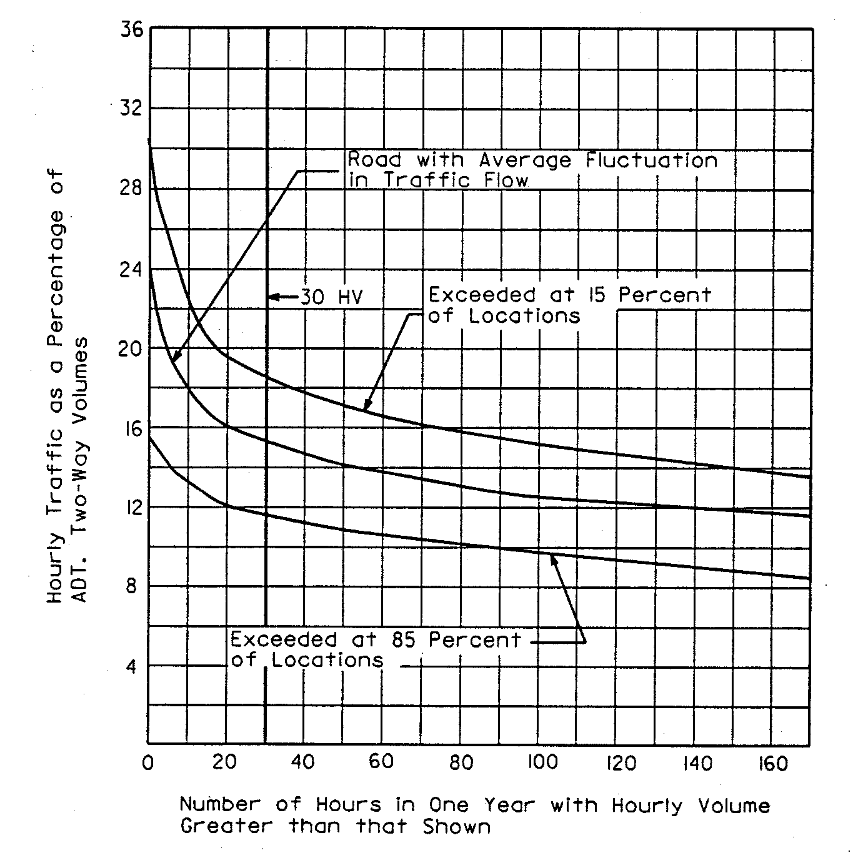

**K**: (Design Hourly Volume Ratio). K-factor represent proportion of AADT that occurs in the 30th HHV.

K-factor = DHV x 100

AADT

K = 8 to 12% urban, 12 to 18% rural.

Example : If AADT is 3500 vpd and the 30th highest hourly volume for the year is 420 vph what is the K-factor for that facility?

* K-factor = DHV x 100

AADT

* K-factor = 420 x 100 = 12%

3500

Question: What’s the impact of choosing different K factor for design? If AADT is 3500 vpd, how will the design volume differ for k-factor = 8% vs. 12%?

**DHV = K-factor x AADT**

**100**

**DHVk=8% = 8 x 3500 = 280 vph**

**100**

**DHVk=12% = 12 x 3500 = 420 vph**

**100**

**(different is 140 veh)**

**D**: (Directional Distribution Ratio) one way volume in peak direction (expressed as a percentage of two-way traffic) 55 to 80% .Use to find Directional Design Hourly Volume (DDHV)

DDHV = K x AADT x D

= DHV x D

Example: If D = 60:40, what is directional distribution of traffic for previous example (Design hourly volume = 420 veh/hr)?

Directional Design Hourly Volume (DDHV) = 0.6 x 420 =252 veh/hr

* Notice we use 0.6 not 0.4!!

**DDHV**: (Directional Distribution Hourly Volume) *Total hourly traffic in critical directions* is used to design two-lane roads. Directional traffic distribution is consistent day by day over years. Measured values can be used for the year of prediction.

Example :Assuming a 60/40 directional split (60% in the peak direction) and a design hour factor (K) is 12%, what is the projected directional design hour volume on this extension? If AADT is 20,000 vec/day

DHV = 2400 vehicle / hr

DDHV = 1440 vehicle / hr / dir.

**Passenger-car equivalent** - The number of passenger cars that displaced single heavy vehicle of a particular type under specified roadway, traffic, and control conditions.

**Peak Hour Volume, Peak Hour Factor, Design Flow Rate**

The peak hour volume: - is the volume of traffic that uses the approach, lane, or lane group in question during the hour of the day that observes the highest traffic volumes for that intersection. The peak hour volume is normally given in terms of passenger car units, since changing turning all vehicles into passenger car units makes these volume calculations more representative of what is actually going on.

The peak hour flow rate is also given in passenger car units/hour. Sometimes these two terms are used interchangeably because they are identical numerically.

*Peak Hour Factor*

The peak hour factor (PHF) is derived from the peak hour volume. It is simply the ratio of the peak hour volume to four times the peak fifteen-minute volume. For example, during the peak hour, there will probably be a fifteen-minute period in which the traffic volume is more dense than during the remainder of the hour. That is the peak fifteen minutes, and the volume of traffic that uses the approach, lane, or lane group during those fifteen minutes is the peak fifteen-minute volume. The peak hour factor is given below.

Peak Hour Factor(PHF) = Peak hour volume/(4*Peak fifteen minute volume)

*Design Flow Rate*

The design flow rate or the actual flow rate, for an approach, lane, or lane group is the peak hour volume (flow rate) for that entity divided by the peak hour factor. A simpler way to arrive at the design flow rate is to multiply the peak fifteen-minute volume by 4. However you derive the figure, most calculations, such as those that measure the current use of intersection capacity, require the actual flow rate (design flow rate).

Example:

It is commonly known in your area that the heaviest traffic flow rates occur between 4:00 PM and 6:30 PM. Your assignment for the day is to find the peak hour volume, peak hour factor (PHF), and the actual or design flow rate for an existing one-lane approach. To do this, you obtain a click-counter and position yourself at the intersection. For each fifteen-minute interval, you record the numbers of right-turns, left-turns, straight-through trucks, and straight-through passenger cars. Your tabulated values are as shown below. If a truck is equal to 1.5 passenger cars and a right-turn is as well, and if a left-turn is equal to 2.5 passenger cars, then calculate the peak hour volume, peak hour factor (PHF), and the actual (design) flow rate for this approach.

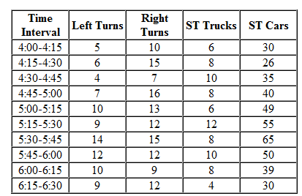

**Solution**

The first step in this solution is to find the total traffic volume for each 15 minute period in terms of passenger car units. This is done by multiplying the number of trucks by 1.5, the number of right turns by 1.5, and the number of left turns by 2.5. We then add these three numbers and the volume of straight-through cars together to get the total volume of traffic serviced in each interval. Once we have this, we can locate the hour with the highest volume and the 15 minute interval with the highest volume. The peak hour is shown in blue below with the peak 15 minute period shown in a darker shade of blue.

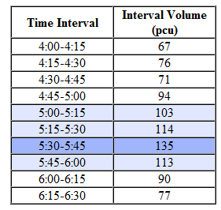

The peak hour volume is just the sum of the volumes of the four 15 minute intervals within the peak hour (465 pcu). The peak 15 minute volume is 135 pcu in this case. The peak hour factor (PHF) is found by dividing the peak hour volume by four times the peak 15 minute volume.

PHF = 465 /(4 * 135) = 0.861

The actual (design) flow rate can be calculated by dividing the peak hour volume by the PHF, 465/0.861 = 540 pcu/hr, or by multiplying the peak 15 minute volume by four, 4 * 135 = 540 pcu/hr.

**Traffic Volume Counts**

Traffic volume studies are conducted to determine the number, movements, and classifications of roadway vehicles at a given location. These data can help identify critical flow time periods, determine the influence of large vehicles or pedestrians on vehicular traffic flow, or document traffic volume trends. The length of the sampling period depends on the type of count being taken and the intended use of the data recorded.

For example, an intersection count may be conducted during the peak flow period. If so, manual count with 15-minute intervals could be used to obtain the traffic volume data.

**USING COUNT PERIOD TO DETERMINE STUDY METHOD**

Two methods are available for conducting traffic volume counts:

**((1)) MANUAL COUNT METHOD**

**Manual counts** are typically used to gather data for determination of vehicle classification, turning movements, direction of travel, pedestrian movements, or vehicle occupancy.

The selection of study method should be determined using the count period which range from 5 minutes to 1 year.

Typical count periods are 15 minutes or 2 hours for peak periods, 4 hours for morning and afternoon peaks, 6 hours for morning, midday, and afternoon peaks, and 12 hours for daytime periods .For example, if you were conducting a 2-hour peak period count, eight 15-minute counts would be required.

Manual counts are typically used for periods of less than a day. Normal intervals for a manual count are 5, 10, or 15 minutes. Traffic counts are usually conducted on ordinary day (Monday, Tuesday, and, Wednesday)

**1-Manual Count Recording Methods**

Manual counts are recorded using one of three methods: tally sheets, mechanical counting boards, or electronic counting boards.

***A-Tally Sheets***

Recording data onto tally sheets is the simplest means of conducting manual counts. The data can be recorded with a tick mark on a prepared field form. A watch or stopwatch is necessary to measure the desired count interval

***B-Mechanical Counting Boards***

Mechanical count boards consist of counters mounted on a board that record each direction of travel. Common counts include pedestrian, bicycle, vehicle classification, and traffic volume counts. Typical counters are push button devices with three to five registers. Each button represents a different stratification of type of vehicle or pedestrian being counted. The limited number of buttons on the counter can restrict the number of classifications that can be counted on a given board. A watch or a stopwatch is also necessary with this method to measure the desired count interval.

**Mechanical Counting Board**

C-Electronic Counting Boards

Electronic counting boards are battery-operated, hand-held devices used in collecting traffic count data. They are similar to mechanical counting boards, but with some important differences. Electronic counting boards are lighter, more compact, and easier to handle. They have an internal clock that automatically separates the data by time interval. Special functions include automatic data reduction and summary. The data can also be downloaded to a computer, which saves time.



**Electronic Counting Board**

There are three steps to a manual traffic volume count:

1. Prepare: Determine the type of equipment to use, the field procedures to follow, and the number of observers required.   
   Label and organize tally sheets. Each sheet should include information about the location, time and date of observation, and weather conditions.
2. Select observer location(s): Observers (data collectors) should be positioned where they have a clear view of traffic and are safely away from the edge of the roadway.
3. Record observations on site.

**(2) AUTOMATIC COUNT METHOD**

Automatic counts are typically used to gather data for determination of vehicle hourly patterns, daily or seasonal variations and growth trends, or annual traffic estimates. The automatic count method provides a means for gathering large amounts of traffic data. Automatic counts are usually taken in 1-hour intervals for each 24-hour period. The counts may extend for a week, month, or year. When the counts are recorded for each 24-hour time period, the peak flow period can be identified.

Automatic counts are recorded using one of two methods:

a-Portable Counters

Portable counting is a form of manual observation. Portable counters serve the same purpose as manual counts but with automatic counting equipment. The period of data collection using this method is usually

longer than when using manual counts. The portable counter method is mainly used for 24-hour counts. Pneumatic road tubes are used to conduct this method of automatic counts .



**Recorder**

**Pneumatic Road Tube and Recorder**

b- Videotape

Observers can record count data by videotaping traffic. Traffic volumes can be counted by viewing videotapes recorded with a camera at a collection site. A digital clock in the video image can prove useful in noting time intervals. Videotaping is not a cost-effective option in most situations. Few small jurisdictions have access to this equipment.

There are three steps to a traffic volume study using automatic counting equipment:

1. Prepare: Coordinate data activities with appropriate state and local officials. For example, you may need to coordinate traffic control activities. Assemble and inspect tools, supplies, and equipment. Test all equipment.
2. Deploy and calibrate data collection equipment: Provide traffic control to protect workers in lanes of traffic.   
   After the equipment is placed, make sure it is functioning properly. Secure it in place.
3. Check data and retrieve equipment